Project Phase2: FlyAway Airline Ticket Booking.

Developed By: shahad ali alsaeed

**Github link : https://github.com/shahadAlthubaiti Email Address :** [**alsaeedshahad5@gmail.com**](mailto:alsaeedshahad5@gmail.com)

# | Project Objective :

The objective of the project is to develop a Website called FlyAway , which is an Airline ticket-Booking website allows users to search for available flights via entering a specific (Date

, Source , Destination , No passengers) And pay for the ticket online.

Also, it allows admin login with the following features :

1. Add new flights
2. List the previous bookings.
3. Change password for admin login.

# | Technologies :

**Frontend** - JSP, HTML, CSS, Bootstrap

**Backend** - JAVA Servlets

**Database** - MySQL

**Application Server** - Tomcat 8.5 -localhost server

## | Project Sprints planning :

## 

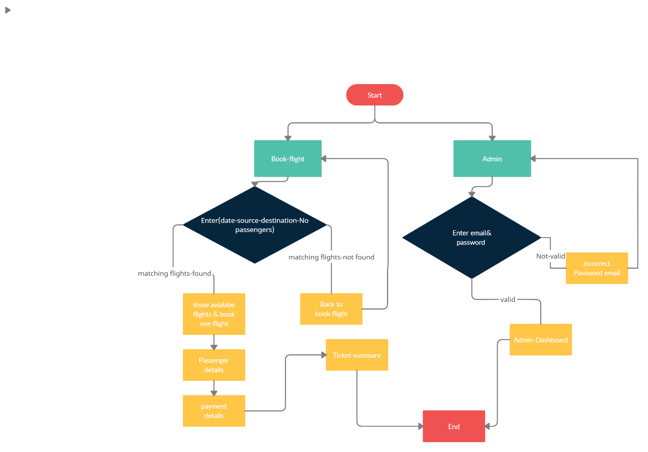**| FlowChart :**